|  |  |  |
| --- | --- | --- |
| **LAB 321Assignment** | **Type:** | **LongAssignment** |
| **Code:** | **J3.L.P0029** |
| **LOC:** | **650** |
| **Slot(s):** | **15** |

**Title:** AP - Architect Partners.

**Background**

### You friend - who are an architect- want to open an online showroom.

Complete this assignment to hep him start hisbusiness as soon as posible☺

Reference site:<http://us-123-architect.simplesite.com/>

**Program Specifications**

Program a web site tointroduce your designed projects, detail functions of this website is described below

**Features:**

This website contains 3 main functions

* Function 1 : Home page : ( see PIC 01)
  + Display introduction entry and short description about : “project” and “About us”
* Function 2 : Project ( PIC 02)
  + Display all project in pictures
* Function 3 : About us( PIC 03)
  + Display “about us” information
* Function 4 : Contact
  + Help user to submit their messages

You do not need to write interface for admin control panel, you can add data manually (use SQL SERVER Management studio).

Note: All data must be load from database, not hard code in page.

***Expectation of User interface:***

Pic 01 : Home Page

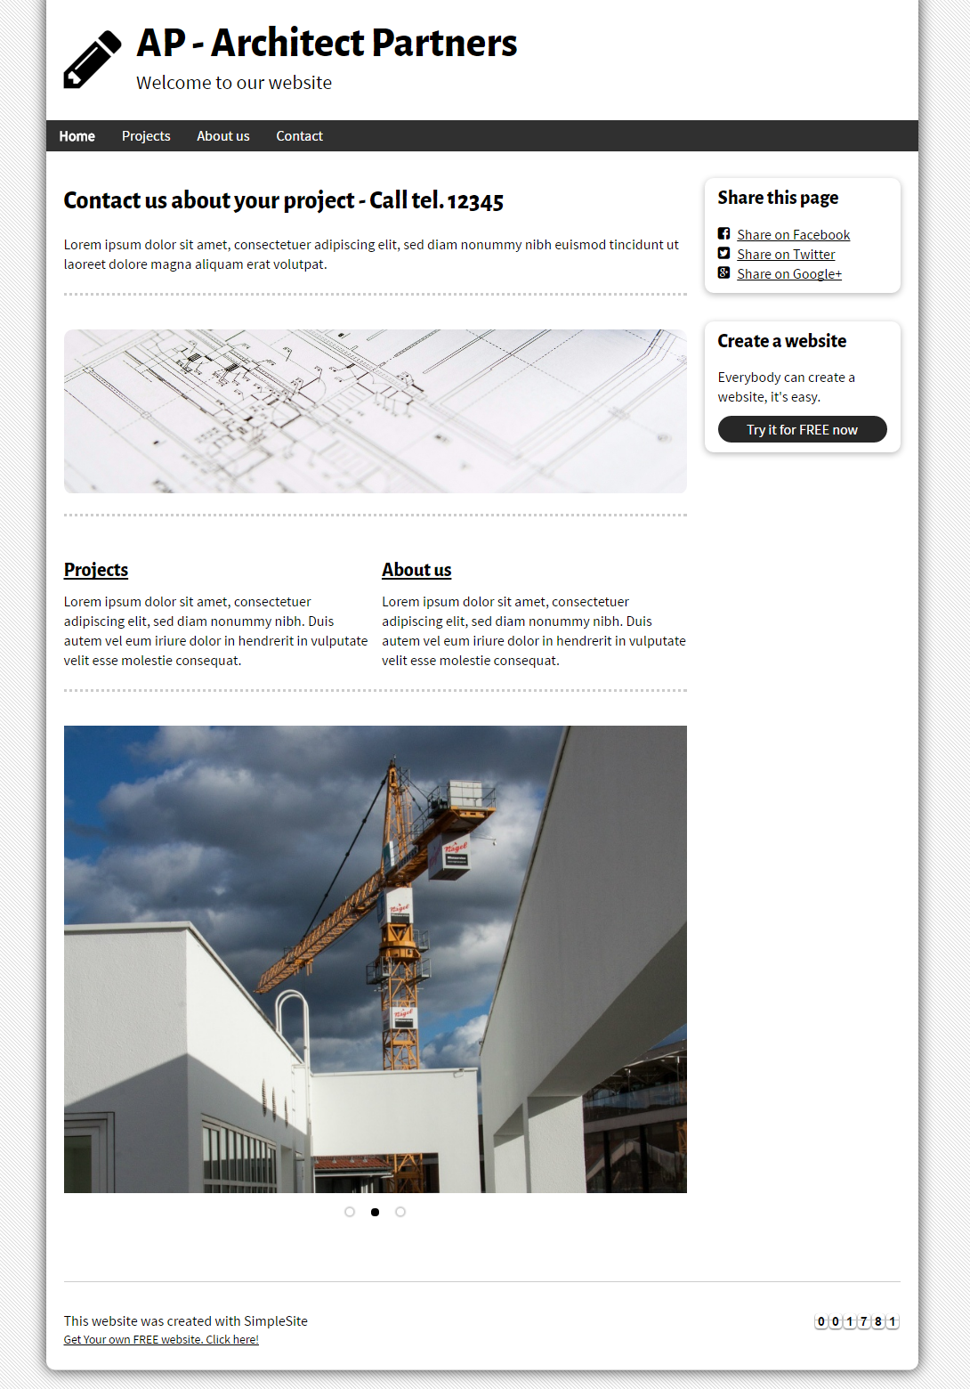

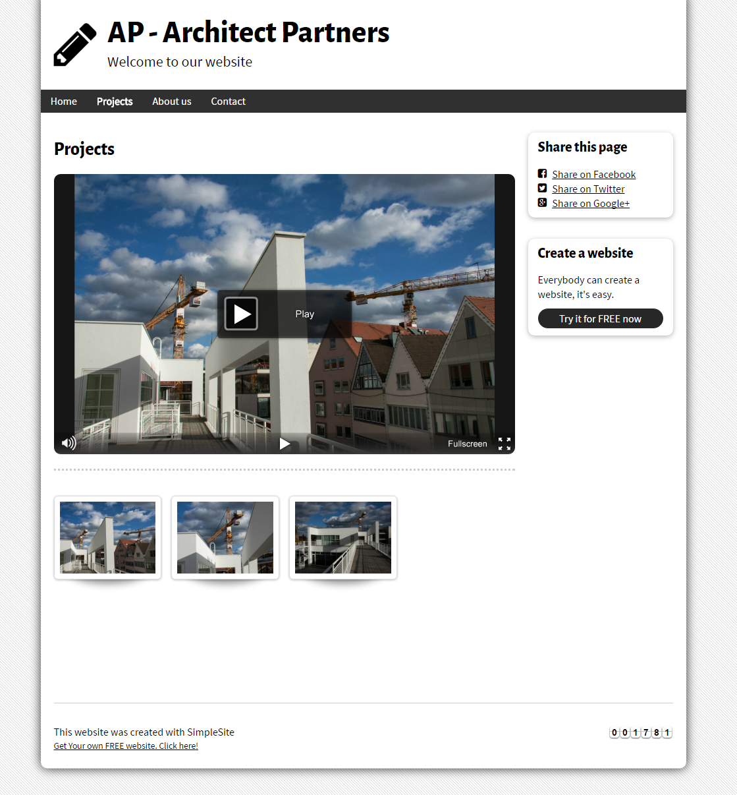

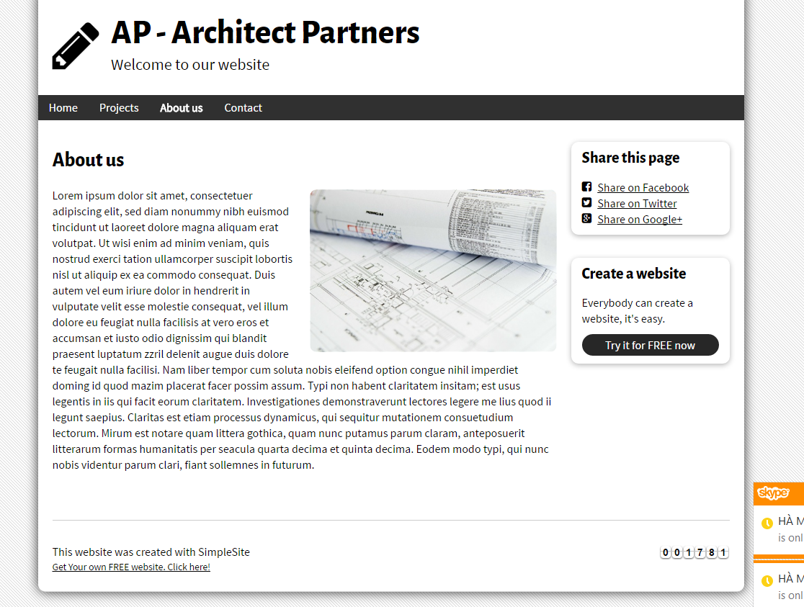

PIC 4 : Contact : allow user to submit message here

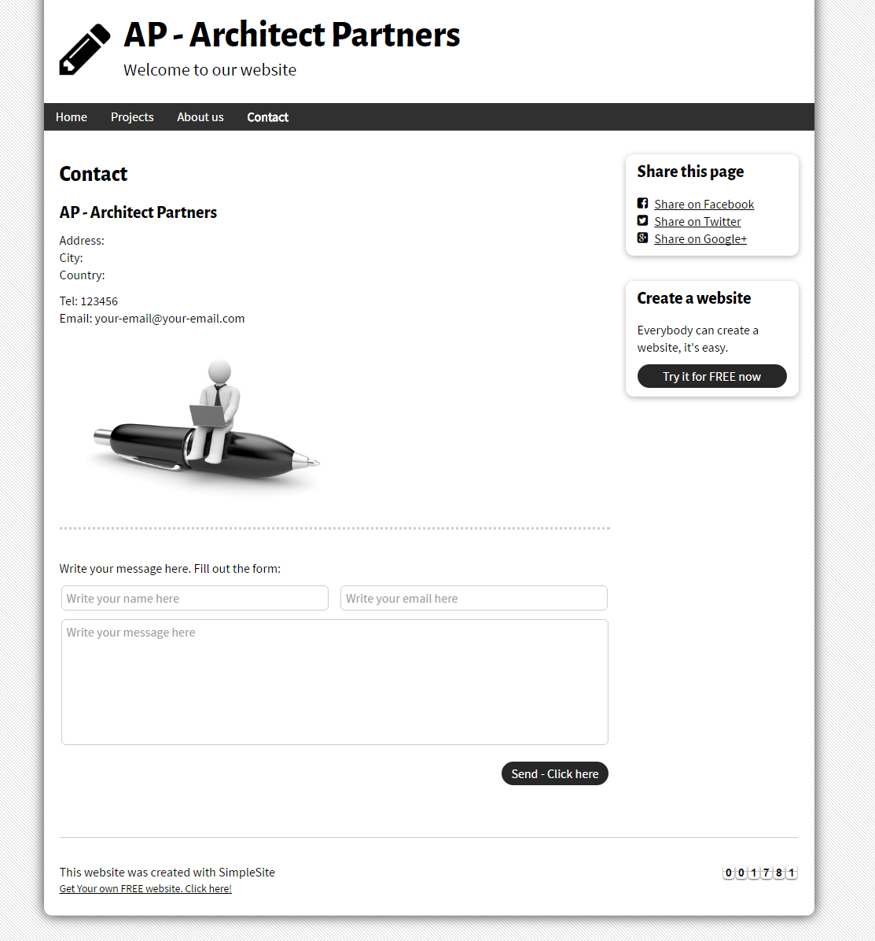

**Guidelines**

* Step 1 : Create web layout
* Step 2 : Create prototype
* Step 3 : Design database base on created prototype
* Step 4 : Code & Test